Applications of Cryptography CSCE 4050/5050 (Spring 2025)
Homework 2
- [Imperfect variant of one-time pad] Consider a one-bit variant of the one-time pad, i.e.,
the key space K = {0,1} and the message space M = {0,1}.
Give a proof that this cipher is perfectly secure.
Please check the attached paper for the answer and explanation below.

- [Stream ciphers are malleable] Suppose that the message “Pay $1000 to Bob” is encrypted using a stream cipher as the ciphertext “7e4d6c73d53e0a948f86951bc29481a5” (in hex).
It is known that the plaintext letters are encoded as 8-bit ASCII characters (see the explanation
on the ASCII encoding below). Provide a modified ciphertext such that its decryption would read “Pay $3000 to Bob”. Explain your answer.
The modified ciphertext that decrypts “Pay $3000 to Bob” is: “7e4d6c73d53c0a948f86951bc29481a5”
Where 3e is replaced by 3c in the ciphertext which is correctly replaced (Check the attached paper for explanation).
Here since we need to change “1” to “3” from plaintext, we just need to change 6th-byte from the ciphertext.
Please check the attached paper below for detailed explanation.

- [Implementation: message encoding] Write a program which converts a text file to its ASCII encoding in hex (and back). The encoding should work as described in the previous question.
(Note that uppercase and lowercase letters have different encodings.)
Create a file “plaintext.txt” and write the sentence “Pay $1000 to Bob” into this file. Print the file “plaintext.txt” to the screen. Your program will take the file “plaintext.txt” as input, convert it into hex (as described in the previous question) and save the result to the file “plaintext_hex.txt”. Print the file “plaintext_hex.txt” to the screen. Then, your program will read the hex string from “plaintext_hex.txt”, convert it to ASCII and print the result to the screen.

Here is the screenshot of the output of the program:

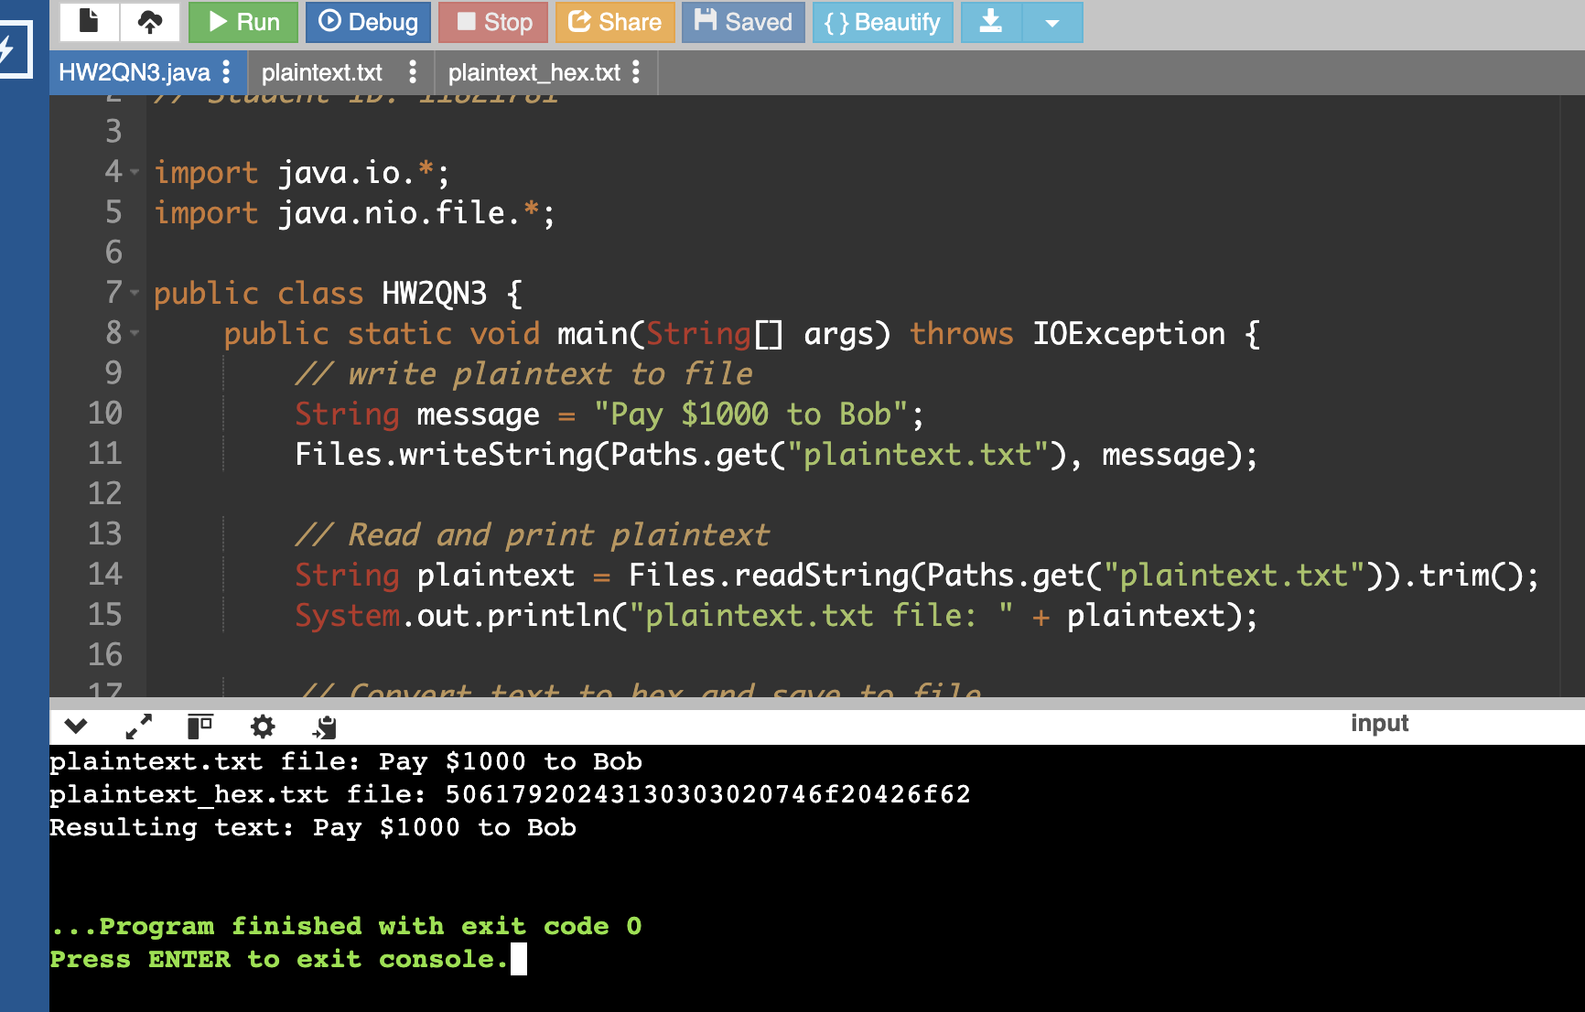

- [Implementation: one-time pad: key generation] Write a program which implements a key generation for the one-time pad. Specifically, the program will generate random bytes, convert them into hex and save the result into a text file “key.txt”. Print the file “key.txt” to the screen. Explain your selection of the method of randomness generation.

Here is the screenshot of the output of the program:

Morever, since this program generates random key for each run, I used this key for other program
OTP key: f38918dbf3670a10ebb450ba258aa68a

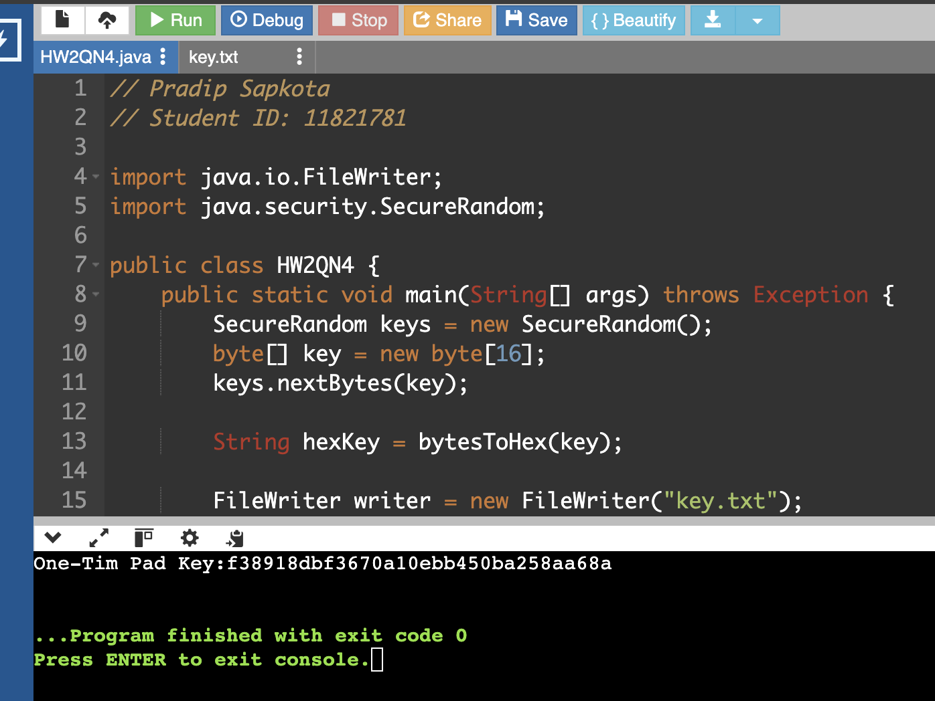

Here, I used SecureRandom for generating unpredictable, cryptographically strong random numbers suitable for use in security applications. The SecureRandom automatically uses high entropy, unlike Random, leading to a key that is hard to predict. In this program, keys.nextBytes(key); securely populates a 16-byte array with random values and converts them to hexadecimal for insertion into key. txt. To ensure this, a one-time pad (OTP) requires that encryption keys are never reused.

- [Implementation: one-time pad: encryption and decryption] Write a program which implements the one-time pad. It will perform the following steps. Read a plaintext from the file “plaintext.txt” (which was created in Question 3) and print it to the screen both as text and as hex. Read a key from the file “key.txt” and print it to the screen in hex. Compute the ciphertext, print it to the screen in hex, and save it to the file “ciphertext.txt” (in hex). Decrypt the ciphertext and save the resulting plaintext to a file “plaintext_dec.txt” as text. Also, print the resulting plaintext to the screen as both text and hex.
Here is the screenshot of the output of the program:
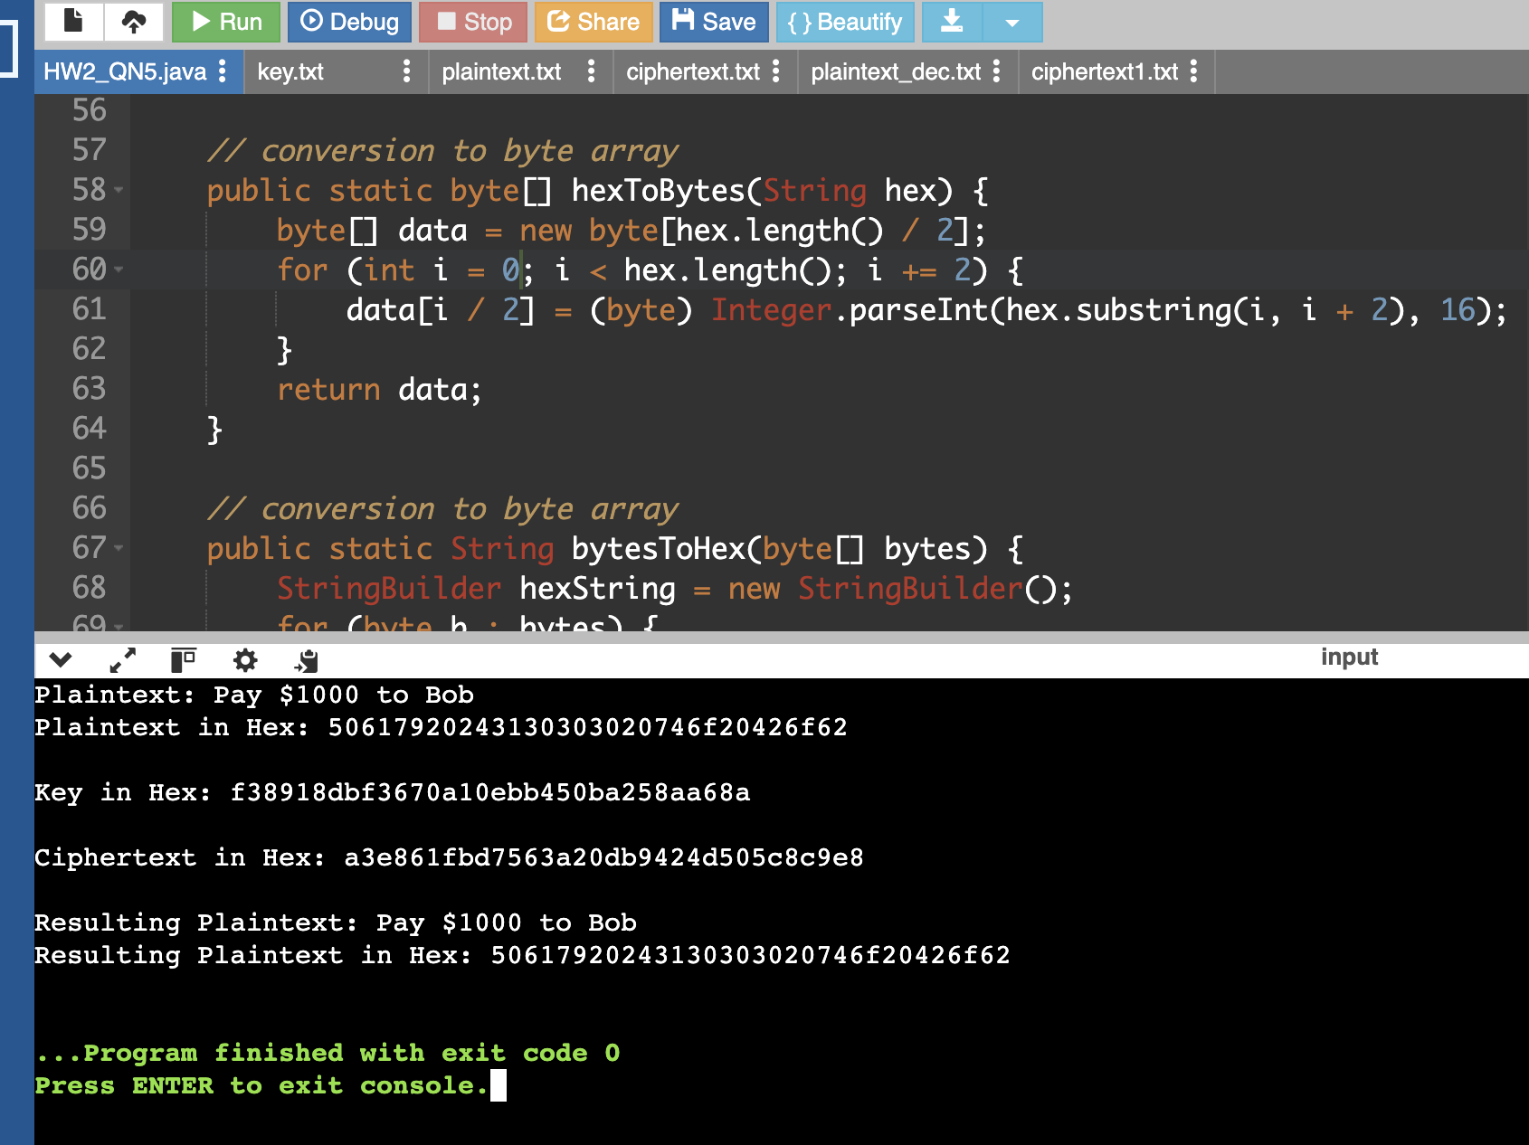

- [Implementation: one-time pad: malleability attack] Copy “ciphertext.txt” to “ciphertext1.txt”
and manually modify the latter file to run the same attack as in Question 2. Specifically, your modification should aim at having the modified ciphertext decrypt to “Pay $3000 to Bob”.
Print the files “ciphertext.txt” and “ciphertext1.txt” to the screen in hex. Your program will decrypt the file “ciphertext1.txt” using the key from “key.txt”, and then print the resulting (modified) plaintext to the screen, both as text and hex.

Here is the screenshot of the output of the program:
Key used: f38918dbf3670a10ebb450ba258aa68a

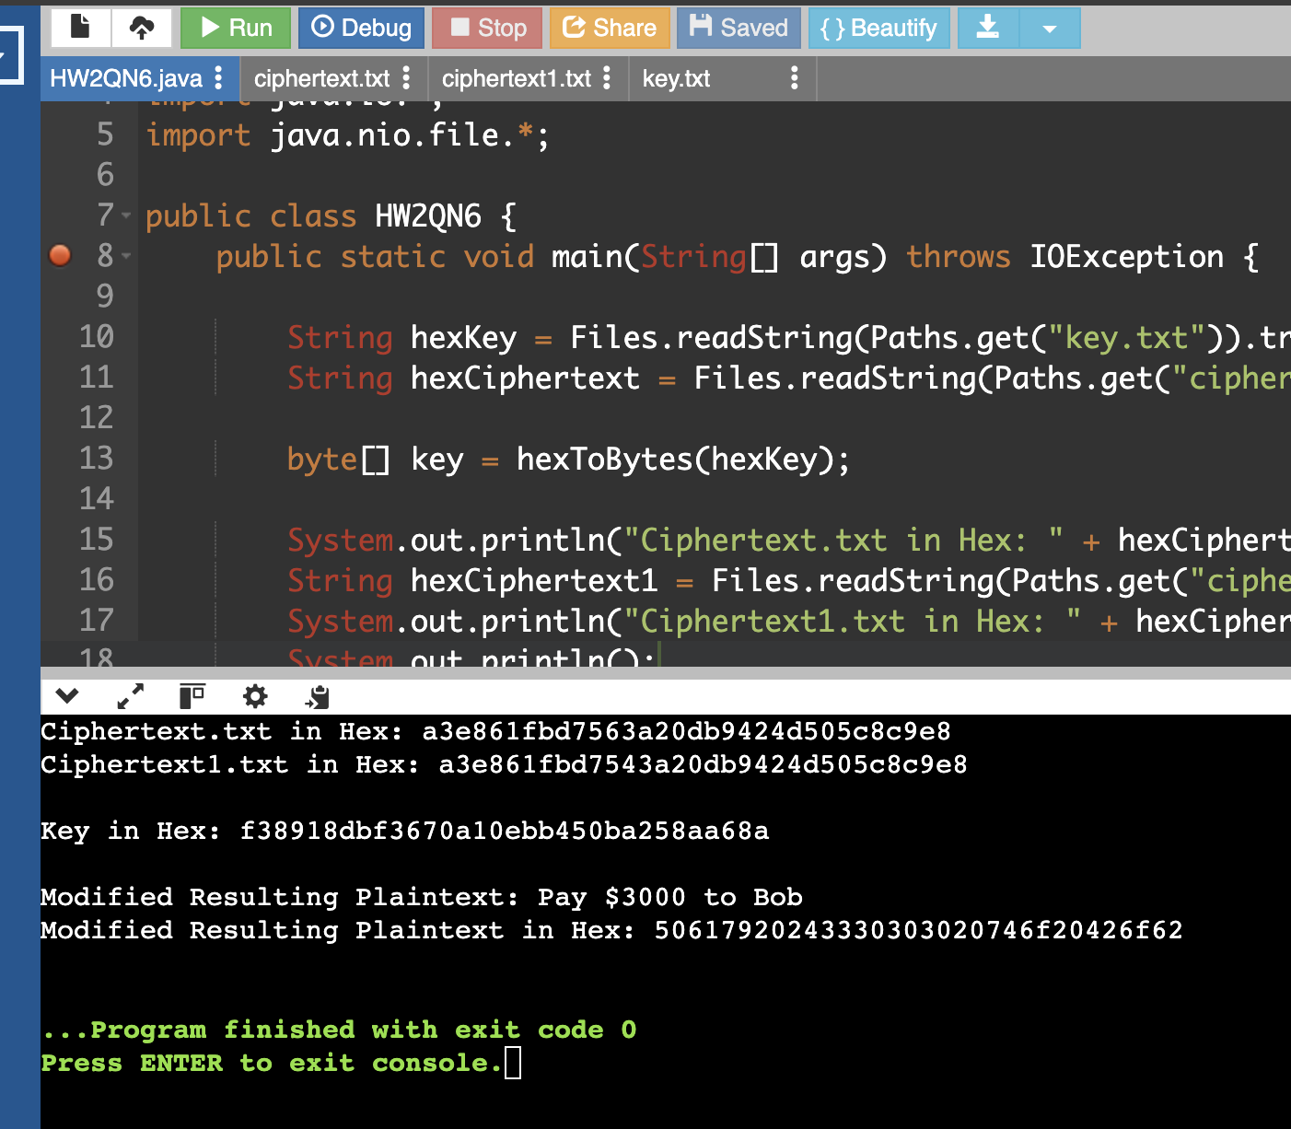

- [Implementation: Two-time pad attack] Let us assume that you are an attacker. Suppose that you intercepted two ciphertexts “f6c735” and “f1ce34” (both are in hex). You know that they were encrypted using the one-time pad and the encryptor used the key twice (their big mistake!). Also, you have an additional information that one of the plaintexts could be “Ali” or “Bob” or “Cho”. Give your best guess what another plaintext is. Explain your answer.
Answer:
Given the context and the plaintext XOR results, the most reasonable pair of m1 and m2 would be m1 = "Cho" and m2 = "Dan". This follows directly from the XOR of the ciphertexts showing how the plaintexts are related when the same one-time pad was repeated. The explanation of how could be these ciphertexts could be “Cho” and “Dan” can be seen on the attached pdf below.
Each potential decrypted name (Ali, Bob, and Cho) has been XORed with the resulting XOR result (070901) in the provided document to find related names (Feh, Efc, and Dan). Given the context and the plaintext XOR results, Dan and Cho make the most logical combination.

